**Introduction and Methodology**

The future of meat consumption in China is unknown. Despite this fact, by performing both quantitative and qualitative analysis on past as well as current trends and data, a baseline forecast can be developed. As relevant trends are investigated, their cumulative impact will be reported. All of the trends considered in the current assessment will be ranked according to their perceived impact on the future. Once the most impactful trends are identified, their cumulative effect will be used to design an expected, surprise free, future.

Data used in the forecasts will come from a variety of sources. The World Bank and Data Planet databases, Statista, Reuters News Agency, the Food and Agriculture Organization of the United Nations, as well as the USDA Foreign Agriculture Service will be beneficial in gathering data regarding relevant trends affecting the Chinese meat industry.

Indicators Measuring the Answer to the Central Question

Meat prices in China are the best overall metric to measure the answer to the central question, “what is the future of meat consumption in China?”. This is because meat prices are a direct result of supply and demand in the meat industry. In order to accurately assess the potential futures for meat consumption the price of meat products must always be taken into account. For example, if meat prices are extremely high, meat consumption is likely to decline. Meat prices are quantifiable and can be used in conjunction with relevant trends to forecast Chinese meat consumption.

Identification of Trends

The following trends impacting the future of meat consumption in China will be quantitatively and qualitatively analyzed. The trends have been ranked in order from most impactful to least impactful.

1. Rising meat prices
2. Rising income
3. Urbanization growth
4. Developments in food technology
5. Import rates
6. Animal disease
7. Changing diets
8. Agricultural technology

Each of these trends were taken into account as the baseline forecast was being developed.

**Trend Analysis and Baseline Forecast**

Demographic: Urbanization Growth

The major demographic trend that affects the meat consumption market is rapid urbanization because urban environments not only decreases the supply of meat producers, but also has a history of increasing the demand for meat. During the Cultural Revolution (1966-1976), many people that lived in the cities were encouraged to move to the countryside in order to promote education and infrastructure improvements in those regions. However, once that ended, there was a huge spike in urbanization during the late 1970s and the early 1980s. According to World Bank Data, 1979 was the year of highest growth with 5.2% movement into cities (World Bank--Urban Population Growth). However, since then the rate of movement has steadily declined to be about 3.2% in 2010. In 2014, China introduced the National New Type Urbanization Plan that’s goal was to move most of the rural population into the cities by 2020. Despite this push to urbanize, the growth rate of urbanization has continued to decline, reaching 2.49% in 2018.

This data does not reflect the percent of the population that are living in urban areas, that, in fact, is increasing. There has been a steady increase of people living in urban areas from 49.2% in 2010 to 59.2% in 2018 (World Bank--Urban Population Growth). Our forecast predicts that China’s percentage of urban population will continue to rise, but at a faster rate. This is based on the assumption that China was frustrated with their inability to move as many rural people as they wanted to in their 2014 New Type Urbanization Plan. In order to solve this issue and consolidate their citizens into the cities, they will develop a stricter plan that will initially cause the urbanization growth rate to spike. It will then plateau as there are not as many people to move into the cities.

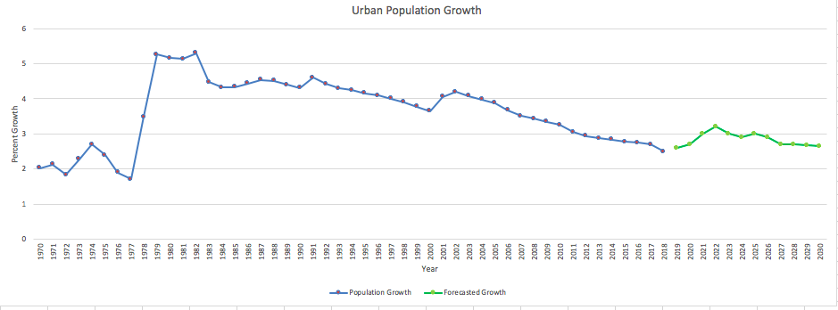

Economic: Rising Income

This economic trend is closely tied with urbanization. As people begin the move to the cities, their incomes rise as they find more stable, well paying jobs. As a growing economy, the total income for China has grown exponentially beginning in about 2000. As a result, the income of a single Chinese citizen has also increased along this exponential trend. In 2000, the average annual income of an urban household was $6,295, whereas in 2019 it is $36,396 (National Bureau of Statistics of China). Some of this increase is due to inflation, however, China and its people have gotten richer and that is reflected in wage growth and the general rise in income.

This has also occurred in rural areas where their income has risen from $2,253 in 2000 to $13,432 in 2017. Despite this significant income gap in China, the rising incomes for every citizen has created a rising middle class that has caused meat consumption to rise. In 2005, there were only 47.7 million people that were considered urban middle class. In 2010, that number had reached 145 million and it has only continued to rise (National Bureau of Statistics of China). The largest market for meat consumption in China is this urban middle class. Therefore, the demand has greatly increased for meat over the years.

This forecast predicts that this trend will continue to follow its current trajectory. As more people continue to move to cities, the urban income will continue to increase as more skilled labor is acquired. Additionally, the rise in income will continue to create a large middle class that will continue to push up the demand for meat and meat related products, as they can now begin to afford it.

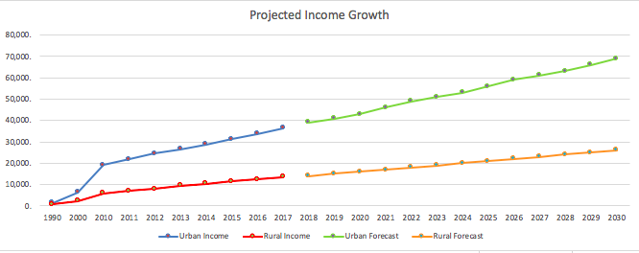

Economic: Rising Meat Prices

As previously discussed, the demand for meat is at an all time high in China with the rapid urbanization and the rising middle class. However, the supply has not been able to keep up with the rising demand because of factors such as animal disease and the plateauing of production capacity, which will be discussed in the environmental trend section. This has caused the prices of meat products in China to soar. The FAO gathers data based on the view of the producer price index. This measure looks at prices from a producers point of view as they witness how prices are fluctuating from consumer demand. In China, the total meat producer price index has gone from 155 in 2014 to 186 in 2016 (Food and Agriculture Organization).

This dataset does not include recent data, but in 2018 the pork supply was greatly diminished by the outbreak of the African swine flu. This caused a 33% drop in the pork supply and has stalled production. Therefore, prices have surged 50% since 2018 and our forecast represents a steeper rise in this producer price index into 2030. Additionally, the Financial Times published a report in which they show how wholesale prices are rising at a much faster rate than retail prices. Our forecast predicts this same steep rise to hit the retail market in the next 5 years due to the fall out from the rising wholesale prices (Yu).

Overall, these rising prices are due to the surge in demand and the steep drop off in supply that China has experienced in the past two years. The rising prices fallout has still not reached its peak and our forecast represents how the rising meat prices will affect the producer price index, which mimics the meat market in China.

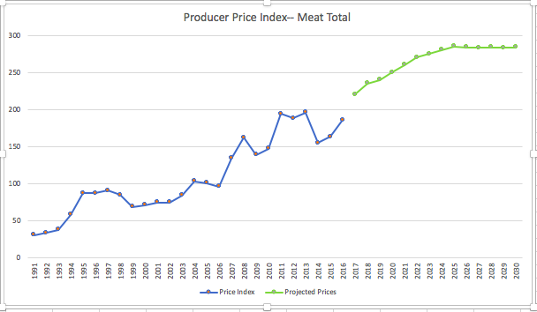

Governmental: Imports of Meat

Due to the high demand in meat consumption, the meat supply in China has not been able to keep pace with the rapid depletion of its resources. This consumption, combined with the increase in animal disease, has affected the pork supply in a particular way, which is a big issue as the holiday season approaches. To quell the prices of this pork, local regions have been releasing its stores to its citizens. However, the situation has gotten so desperate that the central (national) government of China is developing a plan to release their pork stores during the holiday season (He).

With the pork stores already being dug into only a year after the swine flu crisis, the Chinese needs another option to satiate China’s demand for pork and other meat products. This has led to an increase in meat imports over the past 5 years. Even though this mostly affects pork at 76% increase, it also impacts beef at a 50% increase (Patton). The Foreign Agriculture Service reports that the total imports for pork and beef went from 342 MT in 2018 to 575 MT in 2019, and that number has only increased throughout the year. However, the meat consumption crisis in China has given the US leverage to put pressure on the Chinese government to relax the retaliatory tariffs and other restrictions they have on American business. It has become more and more expensive for the Chinese government to import meat (Foreign Agriculture Service).

The current trend shows that imports in China are increasing at a rapid pace, however, the forecast predicts that this trend will slow or even decline as China runs out of options for importing. The Chinese government has closed off their markets to Canada and are showing no signs of relenting to the United States’, the largest beef and second largest pork producer, pressures to lower tariffs. Therefore, their stubbornness and protection of their sovereignty will limit the amount they can import in the future.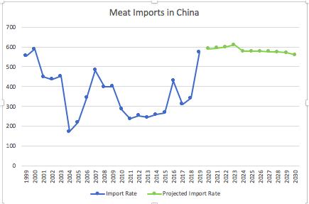

Environmental: Animal Disease

The population growth and increasing urbanization has caused a lack of space in China which has also been felt by the meat production industry. The mega factory farming trend has caused pigs, cows, and chickens to be packed into factories where the living conditions breed widespread disease and death of animals. This has a large impact on supply and promulgates widespread crises such as the African swine flu that hit in 2018.

The forecast represents a steep drop off in hogs due to the African swine flu with a slow recovery due to the slow maturation process of hogs and the continuing crowded conditions of factory life. The number of large animals (cattle), that provide other sources of meat will continue its steady slow decline as they continue to die off due to the living conditions (China Data Institute).

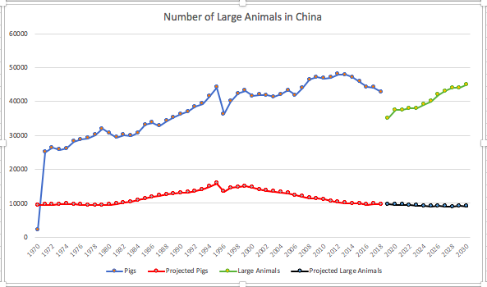

Societal: Changing Diets (Western Influence)

Another trend that ties into rising income is the prevalence of Western influence that has affected the farming styles and the diets of the Chinese people. This began to have an impact in 1979 when the borders between China and the West were opened under the Nixon administration, and information began to flow more freely across the hemispheres.

This trend works in conjunction with rising income, so as Chinese consumers have gained wealth they have mimicked the styles of Western eating as a delicacy. This is seen through the rise in meat as part of the Chinese diet, and a growing amount of the population incorporating meat into their meals. As Bloomberg reports, meat used to be scarce in China, but now with its prevalence due to rising income, the Chinese have made it an essential part of their diet. The issue then becomes, if China only has 0.2 acres per person to produce this meat, how will they keep up with the rising demand of a country of people that are adding more of it to their everyday routine? (Bloomberg News)

This is where the Chinese government is encouraging their people to take after the West. In recent years, Western culture has shifted from a meat based to a more sustainable plant based diet to try and limit the impact we are having on the environment and to focus on health. In response to this, the Chinese government changed their health guidelines to suggest less meat is the healthier option. Therefore, our forecast shows a continuing trend in following Western culture will lower the meat consumption or at least make the growth stagnate in the near future.

Technological: Agricultural Technology:

As mentioned in the societal trend section, China has an increasing demand for meat, but has run out of room to continue producing. They only have 0.2 acres of land per person with the demand being much greater per capita. In order to increase supply, they have turned to agricultural technology in order to keep up their high production rate and make the process more efficient.

China is the largest producer of pork in the world and is competitive in the other meat markets as well. This is due to their large factory farming system that began in the early 2000s. Recently, in order to have room to continue this production, they have rented land in other countries to farm. By being immersed in other industrialized countries, they have been able to develop technological advancements. This includes advanced water, feed, and robot systems that are supposed to speed up the process. However, the rise in agricultural technology has not solved their problem of lack of land and has created more problems with pollution than it has created efficiency. Therefore, our forecast predicts that agricultural technology will have little impact over the next 10 years because China’s problem is not efficiency, but rather not having enough space to keep up with their growing demand and not developing technology in a sustainable way (Bloomberg News).

Technological: Food Technology

After discussing all of the previous trends, the situation looks bleak for China and their ability to feed their people. However, the rise in food technology is leading to the creation of meat alternatives that can replace or support the current supply of ‘real’ meat. China’s plant based meat industry was up 14.2% from last year according to the US Good Food Institute. This is in part due to the skyrocketing meat prices, but also the concern that the meat market is producing contaminated food (Allen).

Since this is a new trend (the first report on plant based meat was published last year), the plant based industry is an additional substitute to consider when analyzing meat supply and demand. China has two certified startups in plant based meat that began in 2018, and that number is only expected to rise. Therefore, our forecast predicts that within the next 10 years the plant based meat industry will skyrocket in China. This will be due to the rising price of real meat, the lack of space to produce real meat, the diminishing supply of animals, and the decline of the environment due to pollution.

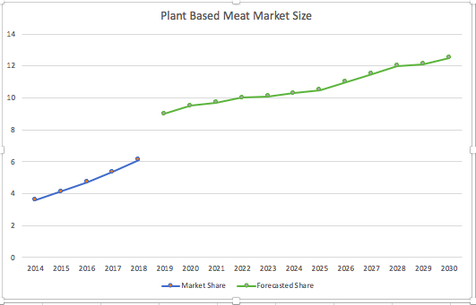

Trend Ranking:

The trends that most affect the meat consumption market are the economic ones including rising income and rising meat prices. The rising income is paired with the rise in urbanization which drives the demand for meat extremely high. In turn, the prices of meat skyrocket in order to equalize this surge in demand. Finally, another very important trend is the huge rise in food technology and greater consumption of fake meat. As prices rise, this gives consumers another market to tap into which will affect real meat consumption. The middle tier trends that do not have as big of an impact are the ones dealing with meat supply, such as animal disease and import rates. These do not have as direct of an effect on meat consumption, but does affect the price through affecting supply. With the increased animal disease, supply is greatly diminished, driving prices up. Conversely, import rates are rising, increasing supply. However, our forecast predicts a slowing of this rise, which will impact how much meat they can put on the market for their people. The lowest tiered trends are impact of Western influence and agricultural technology. The societal trend of Western influence bringing a more sustainable and plant based China will take a lot of time and will only have a very gradual impact as the diets change slowly over a longer period. Similarly, the technological trends will take a longer time than 10 years to fully impact the meat consumption market. The agricultural technology that they currently have is not making production more efficient and is doing very little to solve the animal disease or land shortage crisis.

After this trend analysis, our forecast looked at these various changes in supply and demand to determine how meat consumption will look in 2030. As demand continues to increase with rising income and urbanization, the supply will not be able to keep up due to animal disease and a stagnating import rate. Agricultural technology will do little to solve the production efficiency problem, and the Western sustainable influence will not have a large impact on Chinese diets. Finally, rising food technology provides the Chinese consumer with a viable substitute for real meat. Therefore, as prices rise dramatically with high demand and low supply, meat consumption will plateau and even decrease as meat becomes too expensive and consumers find a good option in the fake meat market.

Source: OECD

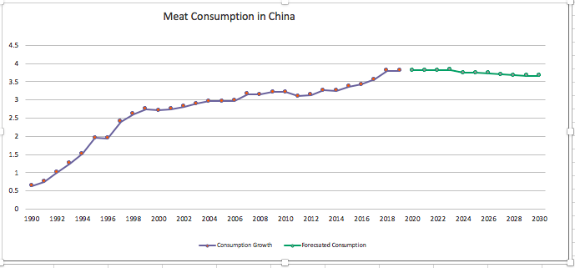

**Narratives of Future Scenarios**

Introduction

After carefully considering different trends and potential disruptions for the meat industry in China, future scenarios were created using the alternative futures method. This method focuses on creating four different future scenarios. These scenarios fall under the categories of, constraint, growth, transformation, and collapse.

The first scenario, Porky Pig (constraint), is the baseline forecast. This scenario is expected to be the future based on current trend analysis. In the Porky Pig scenario, the Chinese government continues to relocate its citizens to urban areas. Wages rise and the demand for meat products surpasses the available supply. The other scenarios are a result of disruptions affecting the meat industry.

The Piglet (growth) scenario is preferred, or the best case scenario. In this situation, the food technology industry has grown significantly, disrupting the traditional meat industry. Meat alternatives are widely available and consumers purchase these products due to a rising interest in sustainable eating. Additionally, the Chinese government opens trade with the United States, another disruption, causing the supply of meat to rise.

In the Miss Piggy (transformation) scenario, food technologies have become extremely advanced, making food an increasingly customized experience. The final scenario, Peter Porker (collapse), is the result of a major disruption in supply. The government does not allow imports of meat, even though demand is through the roof. Farms become more crowded with animals as farmers try to keep up with demand. As animals become sick and die, supply falls and meat prices skyrocket.

Although it is impossible to predict the future, all of these scenarios are within the domain of plausibility. Each scenario, laid out in more detail below, has signposts assigned to them. These signposts will be clues as to which scenario is most likely as time passes.

The figure below represents a Cone of Plausibility for the meat industry in China. The baseline forecast we have created leads to the Porky Pig scenario. Different disruptions along the baseline forecast have also been identified, leading to the Piglet, Miss Piggy, and Peter Porker scenarios. As mentioned before, each of these futures lies within the realm of plausibility.

Cone of Plausibility

Piglet (preferred)

Peter Porker

Porky Pig (expected)

Miss Piggy

Porky Pig – Constraint (Expected)

*Lin wakes up early to the sound of her children, nieces, and nephews arguing over a game of mahjong at the kitchen table. The whole family has gathered to celebrate the Chinese New Year at her house in Shanghai. While the children look forward to the food, the fireworks, and being with their family, the parents understand that this Chinese New Year will not be the same as the rest.*

*Each New Year’s Eve, Lin’s family gathers around the dining room table to make dumplings together. This is a tradition that has been passed on for generations in her family, as dumplings are meant to bring about great wealth in the New Year. Though Lin has searched for pork in the super markets for weeks, the prices have sky-rocketed, and she is just unsure if she will be able to afford it this year. This morning, Lin decides to go to the market one more time with her sisters, in the hopes of finding just enough pork to make the dumplings with their children.*

*Upon arrival, Lin and her sisters discover that the prices are even higher than they had been all week, as most Chinese families are planning on making pork dumplings with their children too. One aisle over from the fresh produce section, Lin notices some families have even resorted to purchasing pork substitutes, as they are significantly cheaper. For Lin, this is simply not an option. Along with her sisters, Lin is able to come up with just enough money to afford the pork to make the children happy, and to carry on their family tradition.*

*Lin returns home to an excited group of children, all of whom are eager to roll the dough, fill the wrappers, and enjoy their delicious creations. Their excitement makes the financial burden worth it for Lin and her sisters, though they are fully aware that next year, they may be shopping one aisle over for pork alternatives.*

In the Constraint Scenario, which is the expected scenario, demand for meat is going to continue to rise, as the Chinese government continues to relocate citizens to cities. This relocation leads to rising incomes, a growing middle class, and a population of people who are hungry for more meat who now have greater access to super markets. This relocation not only increases demand, but also reduces the supply of meat, as there are fewer farmers to produce the meat. The combination of increasing demand and decreasing supply causes the price of meat to skyrocket.

China taps into their emergency pork reserves in order to meet the demand of their consumers, however this solution is merely a band-aid on a problem wound that needs time and attention to fix. Within five years, the reserves have been exhausted. China increases their imports of meat from foreign countries, in order to satisfy demand, but this solution only adds to the issue of rising prices. The short-term increase in overall supply as a result of utilizing the emergency reserves and increasing imports ends, and now supply begins to decline as the remaining wealthy families who can afford meat purchase what remains.

After five years, China realizes the importance of investing in meat alternatives, as a cheaper and healthier replacement to meat. Though many Chinese families are unhappy with this solution, some welcome the product into their kitchens happily. The Chinese government invests heavily into Agriculture Technology in the hopes of someday restoring their meat supply to what it once was.

**Signposts:**

Technology: The investment and furthering of food technology makes meat alternatives a growing possibility.

Environmental: The use of emergency pork reserves is sharply increasing, meaning that there is a decline in the supply of pork.

Economic: China continues to encourage its citizens to move to the cities, thus increasing the income level, and further, the demand for meat products.

Piglet – Growth (Preferred)

*It is 7:00 pm and Yu Yan, a 26 year old woman living in Beijing, heads home from work. As she walks down the busy city streets her mind starts to wander. She thinks about how long the day felt and how she was so ready to be home in the comfort of her apartment. She feels her phone buzz in her pocket and instantly reaches into her pocket to check it. The notification is from Instagram. Her favorite American diet influencer, @bewellbykelly, just created a post. Eager to see what was posted Yu Yan opened instagram. A beautiful picture of a kale caesar salad with a caption reading, “Lettuce Turnip the Beet! What are you doing to make your day plant based?”, filled her screen. Yu Yan liked the picture and returned her phone to her pocket. The post reminded her that she still needed to make dinner. She hurried a few more blocks to her apartment. Once inside she opened the fridge revealing a variety of vegetables and a package of “Beyond Burgers”, a vegetarian meat product. Yu Yan had eaten meat throughout her childhood, but transitioned into a vegetarian lifestyle in adulthood. This change was partially due to Western influencers like @bewellbykelly, as well as healthy eating guidelines that Yu Yan had seen in the news. Yu Yan knew that meat was a lot cheaper than it used to be because of trade with the United States, but for her, following @bewellbykelly’s guide to healthy eating and helping the environment is more important than price. As Yu Yan begins to cook dinner, her mother calls her to talk about food for the holidays, meat is still on the menu.*

In this scenario, the supply of meat is plentiful enough to provide for China’s growing population. The Chinese Government realized that they could not produce enough to feed their people so they opened trade with the United States. This development is extraordinary, as the countries have historically been at odds with one another. Meat producers in China are under less pressure to generate all supply. This leads to a smaller number of animals being farmed causing traditionally crowded farms to increase quality of conditions. The increase in supply seen in the growth scenario also induces a decrease in meat prices. This shrinking price allows more lower class consumers to purchase meat products. Restaurants are also thriving because of lower costs and increased availability of meat products.

Another reason why meat prices have dropped in the growth scenario is that demand for conventional meat products has decreased. Innovation in the food technology industry has allowed meat alternatives to be of a much higher quality and more commonplace than ever before. Chinese consumers are starting to see meat substitutes available in their local supermarkets. As the demand for these replacements increases, more companies will be inclined to begin production, bringing the supply up. Meat alternatives have become an increasingly popular option among consumers as they strive to emulate Western practices of sustainable eating. Chinese consumers also begin to realize the environmental impacts of consuming copious amounts of meat. Consequently, they begin to cut back on consumption as a way to reduce their ecological footprint.

Additionally, meat consumption has decreased because the Chinese health ministry created and published more guidelines regarding meat consumption, urging their citizens to cut back. Consumers who are concerned with negative health implications begin to transition to a plant based diet. All of these factors drive the demand for real meat down.

**Signposts:**

Technology: Further development of food technology allows for widespread alternative meat production

Economic: Increase in meat supply from forigen producers.

Governmental: Relations between the United States and Chinese governments cool off significantly. Allows for increased free trade.

Economic: Subtle decrease in meat demand as well as meat prices.

Miss Piggy - Transformation

*Hui Wang wakes up to the sound of her alarm and she is ready to start the day. She wakes up her son, Lee, and her daughter Soon Yang. Her kids wear this technology to sleep to track their health, moods, school schedules, and taste preferences. Hui takes the biometric technology off her children and then goes to her kitchen to fix up her children’s lunch for school. She hooks the technology up to a screen that transmits data back to her. According to the screen, Lee needs to have a carbohydrate-heavy lunch today before his soccer game later in the afternoon. SoonYang is feeling sad because of friend drama and the screen suggests she eats mood-boosting foods. Hui then looks at the screen of the refrigerator which is also connected to this technology and it tells her what foods Hui should pack for her children based on the data Hui just received and on the current food that they have in their fridge. It also gives a suggestion as to foods she should buy on her next grocery run.*

*After she drops her children off at school, Hui heads to the grocery store. Hui reminisces on her grocery shopping experience back in the days. Food back then was heavy, clunky, and expensive. Grocery shopping was also an exhausting experience as she debated whether to get one brand over another and as she tried to decide what kinds of food to get for her family. Now shopping is a much more enjoyable experience. Shopping is as easy as answering a questionnaire. It asks her income level, her family size, how her family is feeling, and other questions to determine the food she should buy. It then provides her with an optimal list and where she can find all the items. She is very happy when she checks out because it came out to be less than her budgeted spending because of the current low prices of food and the optimized shopping experience.*

In the transformation scenario, agricultural technology and food technology have developed significantly to reverse the negative effects of an increasingly heavy-meat consumption diet in China. Agricultural technology will be able to deal with the negative effects of climate change, rising meat prices, and the low supply of meat. Farms will especially become more reliant on genetic engineering as meat prices continue to rise. Genetic engineering can help create crops that require less water or that are more nutritious. This agricultural technology will also be able to make farming a more precise practice. It can help determine exactly how much water certain livestock or crops require. It can provide other data such the health of animals and the expected increase or decline in supply based on external factors such as government legislation or weather. Because agricultural technology has become more precise, there is less waste within the farming practice. Agricultural technology will also develop methods to store livestock waste in order to decrease the level of carbon emissions. The waste can also be transformed into energy to power the farms in return. The precision will also help decrease the costs of running a farm and therefore decrease the price of meat. Lastly, as precision technology optimizes the farming experience, farmers should be able to match their supply with the demand based on the previous factors mentioned.

On the other hand, food technology will address the problems of a heavy-meat diet which contributes to cardiovascular diseases. Food technology will be able to provide consumers with other sustainable meat options and will develop completely new ways to consume food. This includes breathable foods and food patches. With breathable foods, a person would inhale particles of the food as a mist. Food patches work in a similar way that nicotine patches do. The food patches would stick on to the skin and provide a person with all the supplements, vitamins, and nutrition that they would need. People will be seeing foods they never heard of. The whole food experience is an innovative and creative process. 3d printing and virtual reality in food will become common ways to produce and consume food. People will increasingly turn to these new options as it becomes a new cultural phenomenon. Also technology can create meat alternatives that taste exactly like meat and in this new environment where people are experimenting with new forms of food, they will be much more comfortable with eating meat alternatives. As people become more comfortable with meat alternatives, the decrease in consumption of real meat will help decrease cardiovascular diseases.

Furthermore, food will become an increasingly customized experience. DNA testing will help personalize nutrition. Food technology will help analyze our reactions to food. It can determine what makes us tired, happy, sad, or energized. It will make things taste better because the food has become engineered to fit our food palettes. This will also involve genetic engineering of foods using technology like the CRISPR-Cas9 technology to edit the food genes. Additionally, food technology has helped to create a wholly different dining and shopping experience. Restaurants and groceries will implement these new technologies. There will be a functional foods section: foods optimized for women, men, children, elderly. This is because these technologies have helped us determine what kind of foods are best for each demographic group. Restaurants will also be able to incorporate a more expansive dining experience to serve all kinds of customers. They will be able to have custom-designed foods based on flavor preferences, dietary restrictions, and dietary needs.

**Signposts:**

Technology: significant technological advancements that change the shopping and dining experience

Cultural: experiential dining restaurants will become more common and eating practices/lifestyles will be more dependent on technology

Government: More regulations and ethical guidelines on genetically/scientifically modified foods and high-tech farming practices

Economic: The price of meat will go down as meat substitutes become popular

Peter Porker - Collapse

*The clock finally strikes 5:00 PM and Ying Yue breathes a sigh of relief. She can finally pack up and start making her way home for the night. As she steps outside for the first time since early this morning, the brisk Beijing wind hits her face and sends chills running down her back. It seems like the temperature drops every day since December began, and Ying knows that snow is not far away. Normally she adores the snow, but the decreasing temperatures are a mere reminder of the quickly approaching holiday season. Ying loves to cook, and the past few years the holidays have been her excuse to produce an eclectic, mouth watering spread of various pork and beef dishes. It is the one thing that she has always been able to contribute to the family gatherings, but this year she is worried that she simply won’t be able to afford it. Over the past few months, meat prices have skyrocketed, and she does not see an end to the rise anytime soon. Most weeks she skips even bothering heading to the meat market, knowing that the supply will be frugal and three times the normal price. She opens her phone to once again try to research new meat alternatives that she might be able to work with, but the options remain few and far between. It seems everyone is more concerned with trying to increase the supply of actual meat rather than try to focus on alternative solutions - a concept that has not been working.*

*She closes her phone as she approaches her apartment and heads up to her room. She flips on the TV in an attempt to distract her mind from the stress of holiday dinner, but a familiar monologue starts playing. “Another Chinese resident has been hospitalized with African Swine Flu, doctors say..”. She quickly turns the TV off. Ying is starting to realize that, even if she can save up some money to afford her meat enriched holiday dinner, it may not even be worth the risk. This ASF epidemic is getting serious, and Ying has become a little paranoid. She could resort to this “alternative” method of meat purchasing that she has been hearing about at work, but one of her coworkers got sick from trying to purchase under the law, and she would not want that to be one of her family members. With all of that in mind, realizing a solution is not in near view, she stands up and starts on dinner - vegetarian lasagne, again.*

In the Collapse scenario, the Chinese government continues to refuse to accept imports from the United States. In addition to this, the diseases among Chinese livestock continue to worsen and kill off ample amounts of supply. Chinese residents continue to be inflicted with the disease, and the death tolls rise. Demand does not lessen, and the decreasing supply causes prices to skyrocket. Although some companies in China have been researching new food and agriculture technology, the advancements are not progressed enough to level out the constant increase in demand and a sharp decline of available supply. Restaurants try to work around their menus, but with meat having been such a staple in everyones’ diets recently, they do not have much to work with. A lot of places start to go out of business, either from too high of prices or a lack of a flexible vegetarian menu that people actually want to eat.

Those who were accustomed to consuming meat everyday can now barely afford to eat it a few times a week. However, many residents want to continue to hold on to this new, higher end lifestyle, and thus resort to unsafe alternatives to purchase meat products. An equivalent to a meat “black market” rises in popularity, but it does not have the same governmental health and sanitary restrictions that normal grocery stores and restaurants have to abide by. Due to this, contraction of disease becomes even more likely, and more people start getting sick. The ASF is becoming an epidemic, and no cure is yet to be discovered. To try to counter this, the government simply puts stricter health restrictions on meat vendors, but this does not ever really trickle down to the black market sellers. Rather, it only implicates more expensive screening procedures for restaurants and legal food markets.

To try to increase production, the government, and the large meat corporations continue to do what they have been doing. They produce more “mega farms” to try to get meat supply up. However, the conditions still have not changed, and these farms are not able to operate efficiently enough. Animals continue to be too cramped, and disease continues to spread among them, killing off much of the supply. Waste control continues to get out of hand, and the spillage starts affecting a lot of water and alternative crop sources in China. They continue to destroy, or try to use, copious amounts of land for meat production to try to keep up with demand rather than accepting defeat and looking for alternative food sources.

In this worst case scenario, the government cannot afford to feed their people. They are not only losing their own supply, but they are also losing large amounts of money from the meat that they used to export to other countries. With increased diseases and prices, many countries started looking for alternative suppliers of meat, and China continues to lose revenue. The stubbornness of the government is only making China more and more separate from other countries, and with the holiday season approaching, it looks like most of the population will not be able to serve meat on their tables.

**Signposts:**

Technology - There are not enough food and agricultural tech advancements to counter the decreasing meat supply and be able to keep up with the increasing demand for meat.

Government - The Chinese government does not open their imports up to the United States and begins losing exports.

Economic - The prices of meat skyrocket.

Environmental - The spread of disease continues to worsen both for livestock and Chinse residents.

Economic - A lot of restaurants and markets start going out of business due to increased prices. Consequently, a meat “black market” increases in popularity, but safety restrictions are nonexistent.

Conclusion

The cumulative effects of the relevant trends including: rising consumer income due to urbanization, rising meat prices resulting from increased demand, rising meat prices due to a lack of supply, and development of food technology will bring the Chinese meat industry to the expected scenario. In this Porky Pig world, demand for meat is greater than supply and many citizens are unable to purchase meat, even though their incomes are higher. Many families are required to switch to meat alternatives as a result of high prices. In the preferred scenario, Piglet, the demand for meat decreases due to a greater availability of meat alternatives and an increased cultural emphasis on sustainable eating. Supply in this scenario increases as the Chinese government opens up trade, bringing the price of meat down considerably. Miss Piggy results from exponential food technology growth. The final scenario Peter Porker relies on the facts that the Chinese government will continue to restrict trade and industrial farmers will become overwhelmed with demand. Animals are dying and people are not able to buy meat at the astronomical prices being charged. Each scenario is plausible, resulting from a variety of potential disruptions to the Chinese meat industry. All of these scenarios will result in distinct potential for businesses in the future.

References

Allen, Mary. “New GFI Report Illustrates the State of China's Plant-Based Meat Industry.” *Good Food Institute*, Good Food Institute, www.gfi.org/new-gfi-report-illustrates-the-state-of-chinas.

Bloomberg News. “Farming the World: China’s Epic Race to Avoid a Food Crisis.” *Bloomberg.com*, Bloomberg, www.bloomberg.com/graphics/2017-feeding-china/?mc_cid=9feabbbef1&mc_eid=aafe86284f.

He, Laura, and Serenitie Wang. “China Is Starting to Eat into Its Emergency Reserves of Pork.” *CNN*, Cable News Network, 12 Sept. 2019, www.cnn.com/2019/09/12/business/china-pork-reserves-african-swine-fever/index.html.

Patton, Dominique. “China's Pork, Beef Imports Surge in September.” *Reuters*, Thomson Reuters, 15 Oct. 2019, www.reuters.com/article/us-china-economy-trade-meat/chinas-pork-beef-imports-surge-in-september-idUSKBN1WT070.

Yu, Sun. “Soaring Chinese Meat Prices from Swine Fever Threaten Retail Crisis.” *Financial Times*, Financial Times, 27 Oct. 2019, www.ft.com/content/014a0f72-f642-11e9-a79c-bc9acae3b654.

Datasets

China Data Institute (2019-04-01). China Yearly Statistics (National): Agriculture | GroupCode: 142201.b0201 | Socioeconomic Indicator: Number of Large Animals at Year End - Period end value, 1949 - 2018. Data Planet™ Statistical Datasets: A SAGE Publishing Resource. (Dataset). Dataset-ID: 035-001-010. <https://doi-org.proxy.library.nd.edu/10.6068/DP16E46846A5A67>

China Data Institute (2019-04-01). China Yearly Statistics (National): Agriculture | GroupCode: 142203.b0201 | Socioeconomic Indicator: Number of Hogs at Year End - Period end value, 1949 - 2018. Data Planet™ Statistical Datasets: A SAGE Publishing Resource. (Dataset). Dataset-ID: 035-001-010. <https://doi-org.proxy.library.nd.edu/10.6068/DP16E4683C57066>

Food and Agriculture Organization of the United Nations, Statistics Division, Food and Agriculture Organization of the United Nations (2019-07-16). Food and Agriculture Organization Statistics: Prices - Producer Price Indices | Country: China | Item: Meat, Total | Element: Producer Price Index (2004-2006 = 100) -, 1991 - 2016. Data Planet™ Statistical Datasets: A SAGE Publishing Resource. (Dataset). Dataset-ID: 067-001-009. <https://doi-org.proxy.library.nd.edu/10.6068/DP16E3EB3763228>

Foreign Agricultural Service, United States Department of Agriculture (2019-07-14). World Agricultural Production, Supply, and Distribution: Agricultural Commodities | Country: China | Commodity: Meat, Chicken | Attribute: Imports, 1999 - 2019. Data Planet™ Statistical Datasets: A SAGE Publishing Resource. (Dataset). Dataset-ID: 008-007-001

National Bureau of Statistics of China. “Annual per Capita Disposable Income of Rural and Urban Households in China from 1990 to 2017.” *Statista* , Oct. 2018, [www.statista.com/statistics/259451/annual-per-capita-disposable-income-of-rural-and-urban-households-in-china/](http://www.statista.com/statistics/259451/annual-per-capita-disposable-income-of-rural-and-urban-households-in-china/).

OECD (2019), Meat consumption (indicator). doi: 10.1787/fa290fd0-en (Accessed on 10 November 2019)

World Bank. “Urban Population Growth.” World Development Indicators, The World Bank Group, https://databank-worldbank-org.proxy.library.nd.edu/source/world-development-indicators#advancedDownloadOptions